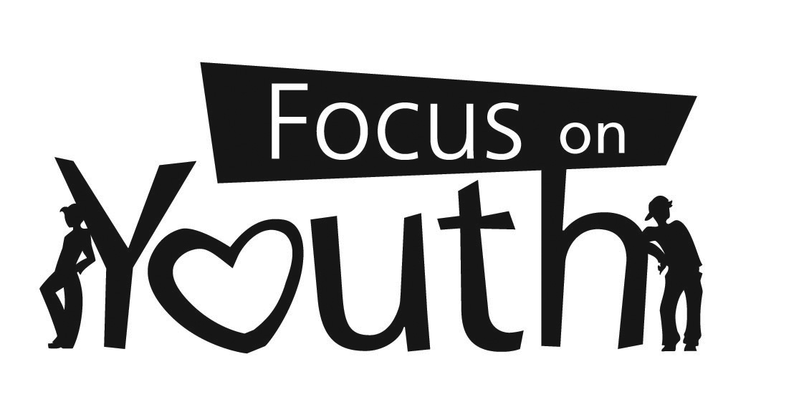

Direct Deposit Worksheet

I hereby authorize Focus on Youth, Inc. to initiate electronic credit entries and, if necessary, debit entries to reverse erroneous credit entries to my account(s). It is agreed that these deposits will be made in accordance with the rules of the National Automated Clearing House Association (NACHA).

Checking Account Amount:

Checking Account Amount:

Savings Account Amount:

Credit Union Amount:

FOR FULL AMOUNT, INDICATE 100%

The authority shall remain in full force and effect until Focus on Youth, Inc., has received written notification from me of its termination in such time and in such a manner as to afford Focus on Youth, Inc. and the bank a reasonable opportunity to act upon the termination request.

A VOIDED CHECK MUST BE ATTACHED FOR ALL CHECKING ACCOUNTS

A DEPOSIT SLIP MUST BE ATTACHED FOR ALL SAVINGS ACCOUNTS

Printed Name Date

Signature SS#

