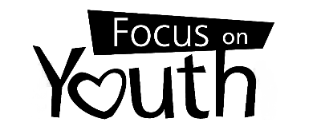

## Release of Information

I, , am the parent of the following child(ren):

, born

, born

, born

, born

, born

, born

I authorize the Hamilton County Juvenile Court to release the delinquency, unruly and traffic records of the child(ren) to the following agency:

Focus on Youth, Inc. Whose address is:

8904 Brookside Ave.

West Chester, OH 45069

To verify this authorization, I can be reached at ( ) .

Signature

Address Date

# Mail this form to Hamilton County Juvenile Clerk of Court, 800 Broadway, Cincinnati, OH 45202